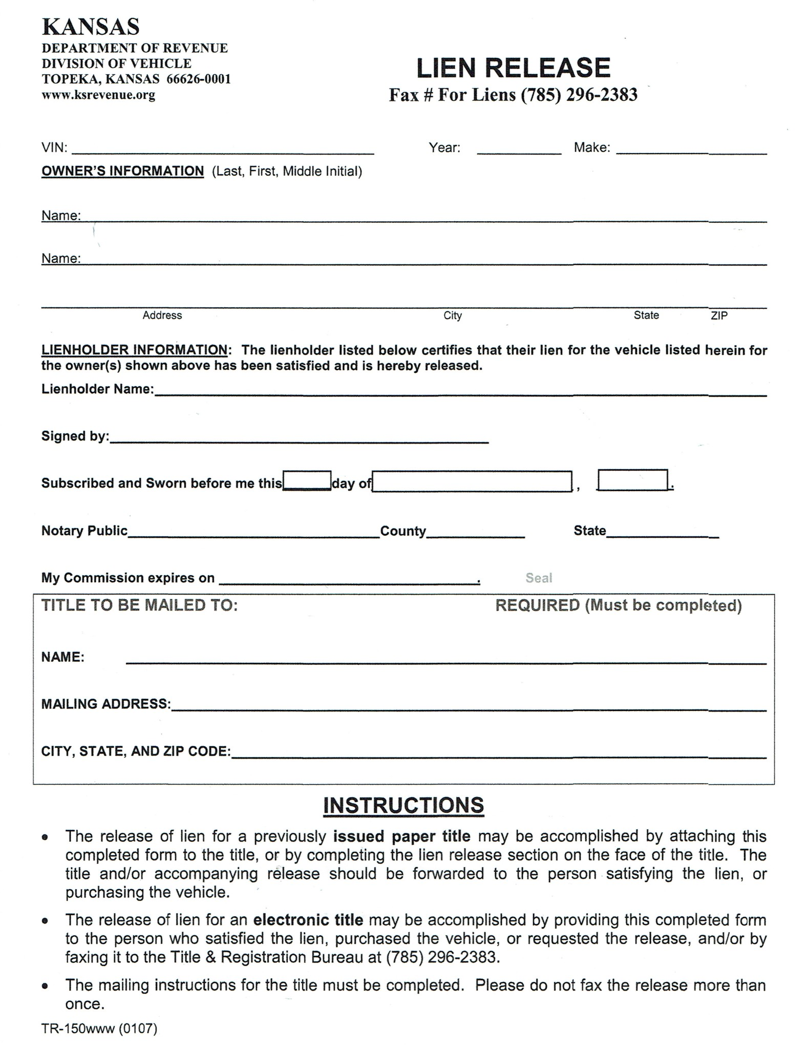

[City]

[State]

[Zip]

[Address]

[Owner]

[Zip]

[State]

[City]

[Address]

[CoOwner]

[Owner]

[Make]

[Year]

[VIN]